**Name: Kanak Agrawal**

**Email:** [**Kanakagrawal2001@gmail.com**](mailto:Kanakagrawal2001@gmail.com)

**Date: -20-02-2024**

**Day-22 Assignment(Azure)**

**Hand written Notes**

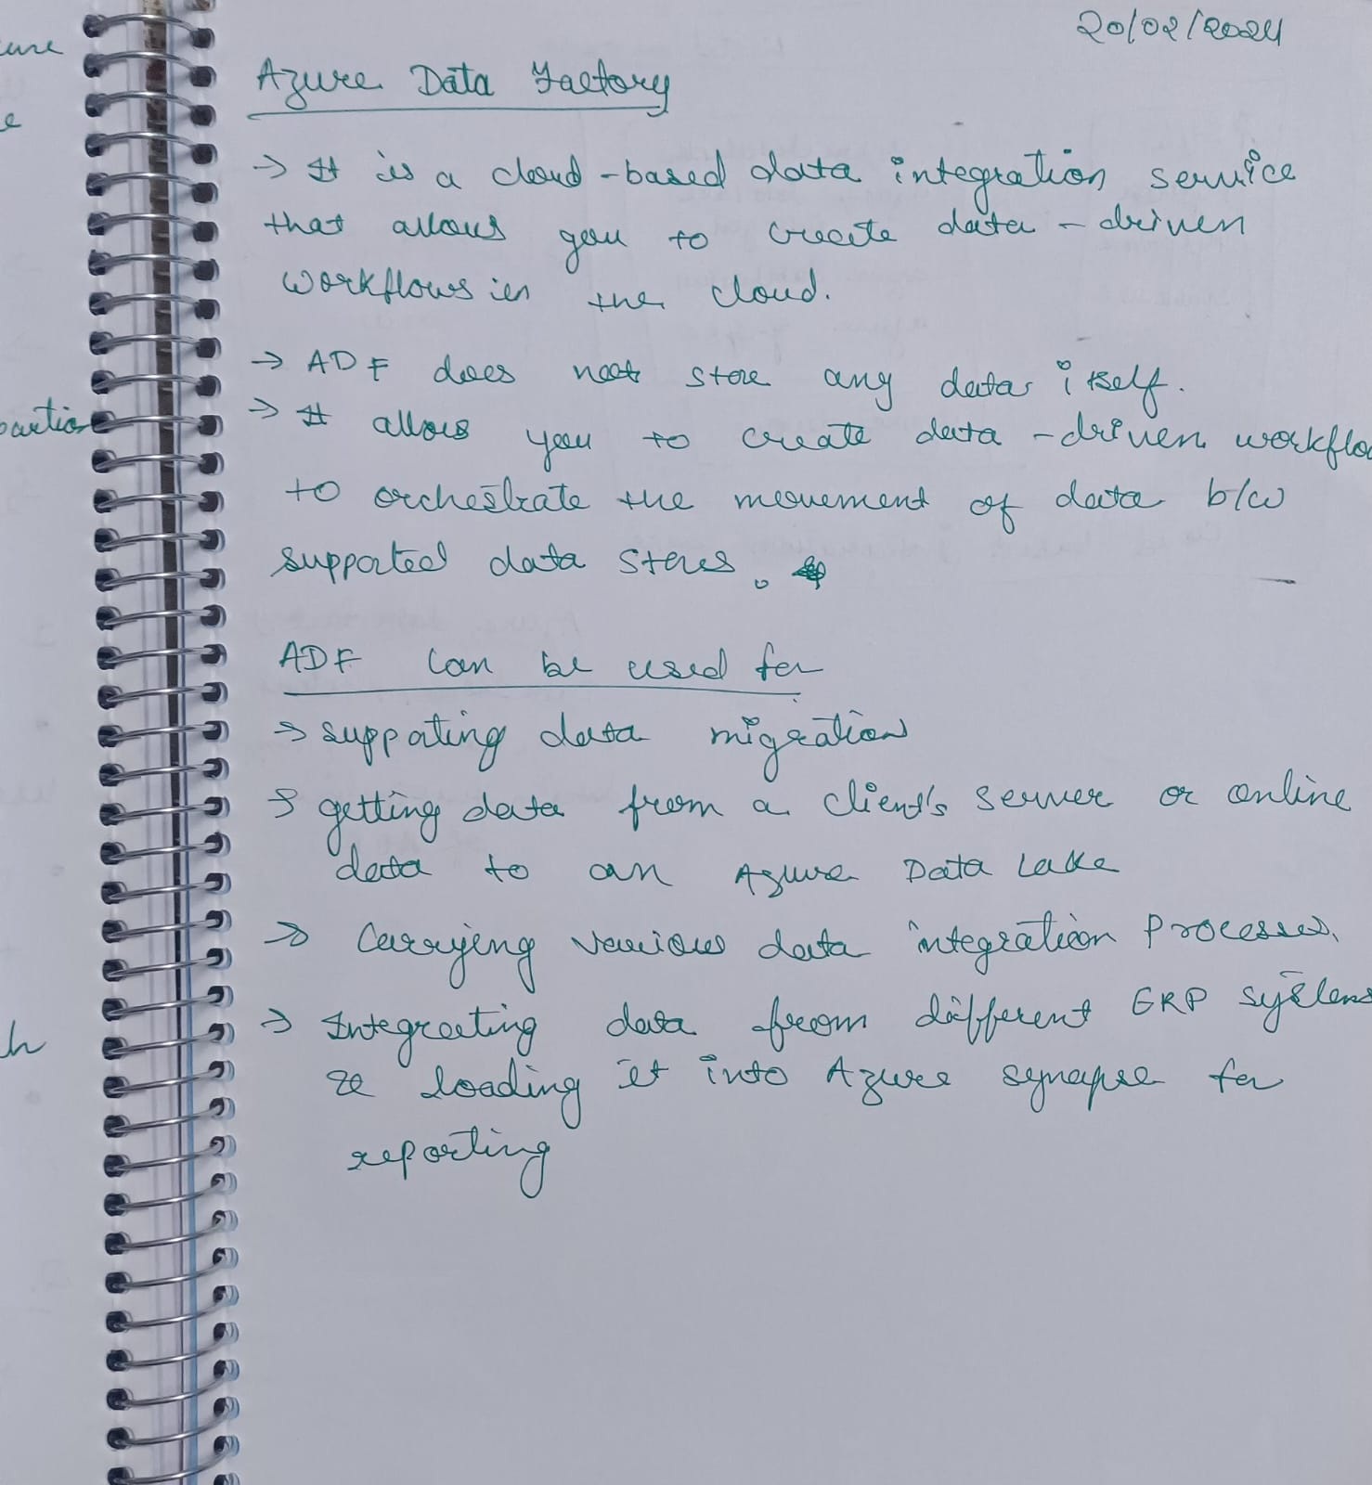

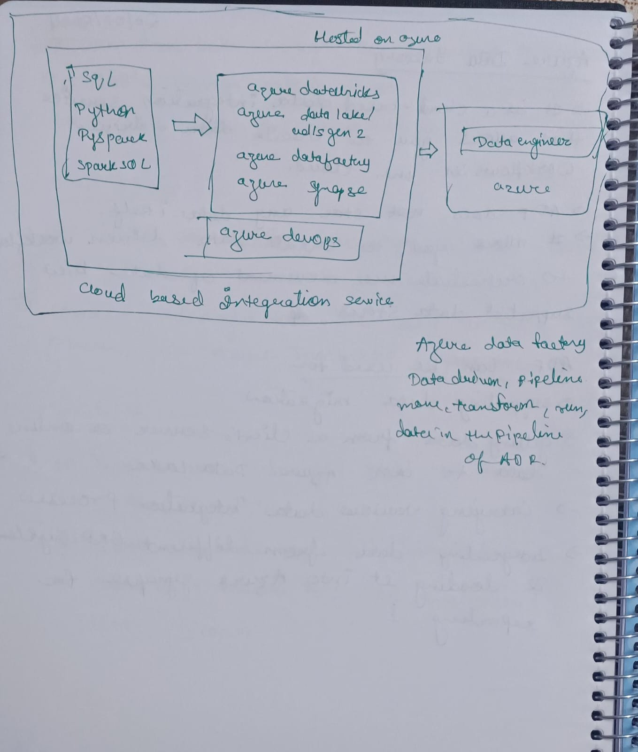

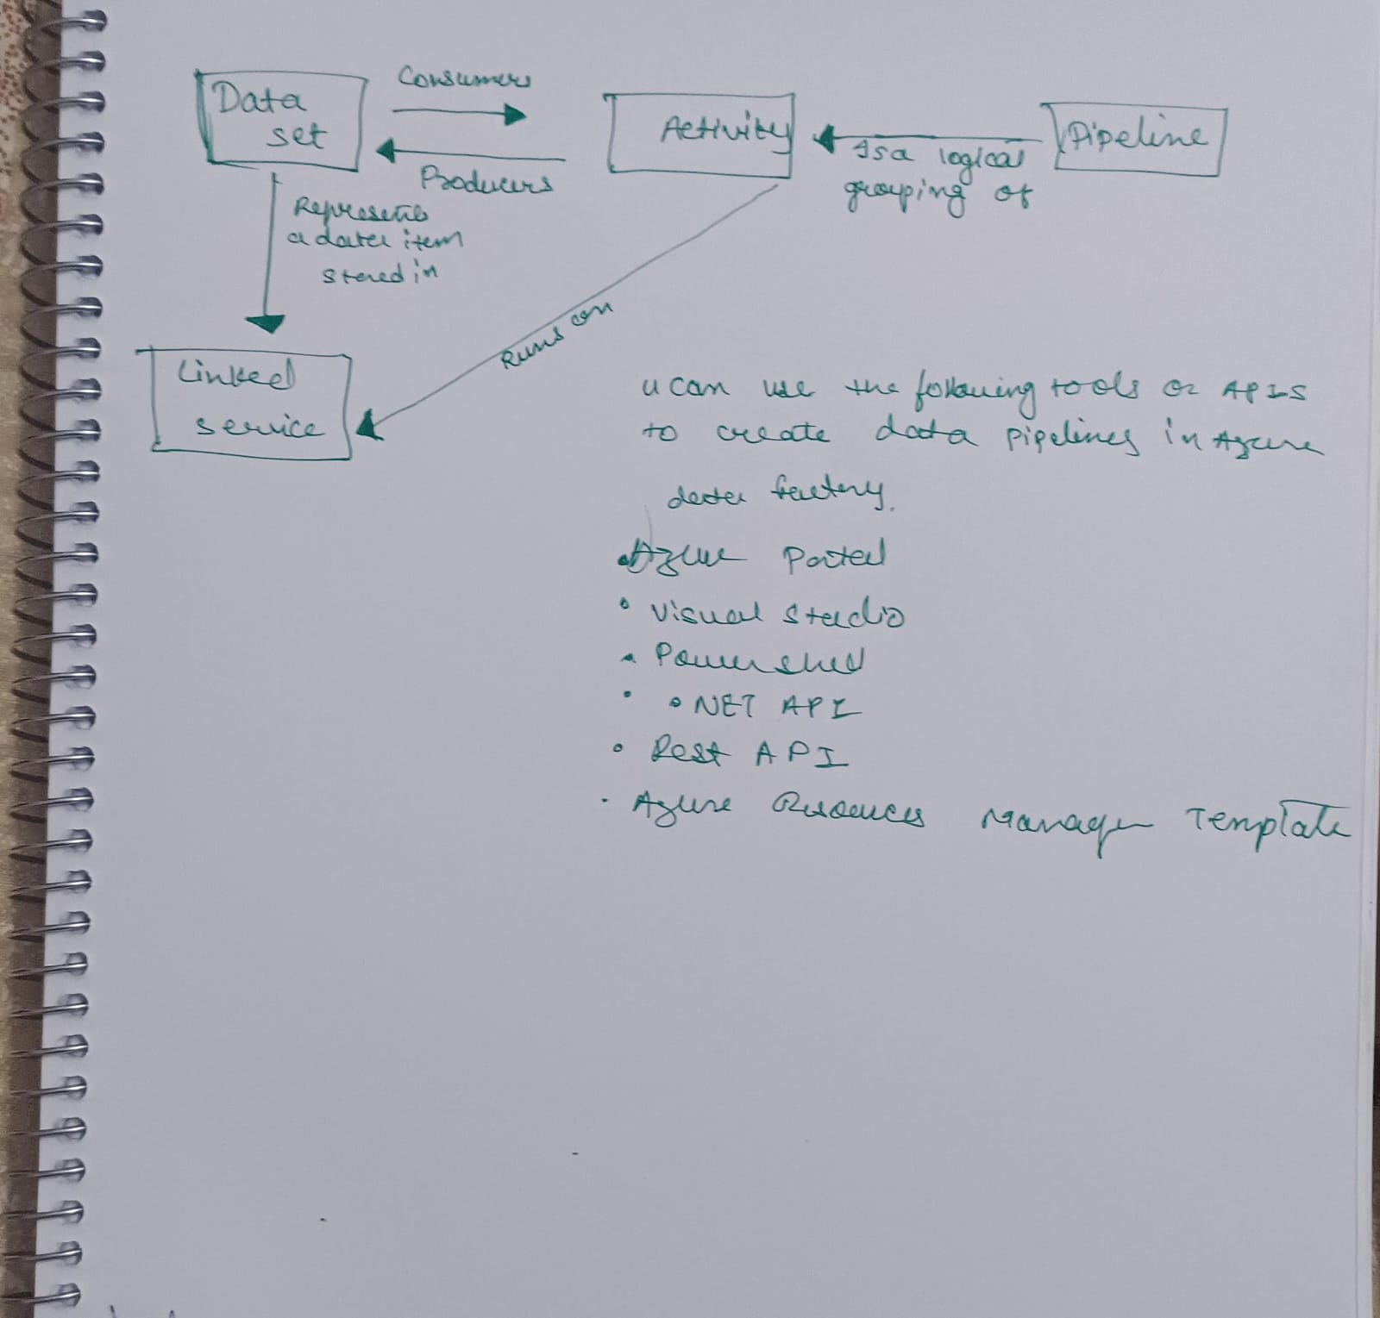

**Creating a Azure Data Factory**

